**CP Club 365Days Challenge**

**Programming language – c++**

**Problem Statement**

[https://practice.geeksforgeeks.org/problems/ishaan-loves-chocolates2156/1?page=1&difficulty[]=-1&category[]=Arrays&sortBy=accuracy](https://practice.geeksforgeeks.org/problems/ishaan-loves-chocolates2156/1?page=1&difficulty%5b%5d=-1&category%5b%5d=Arrays&sortBy=accuracy)

**Your Code**:

// 0x51Day of 0x365Days challenge

// VEDANT BHARAD

// 07-12-2022

//{ Driver Code Starts

#include<bits/stdc++.h>

using namespace std;

class Array

{

public:

    template <class T>

    static void input(vector<T> &A,int n)

    {

        for (int i = 0; i < n; i++)

        {

            scanf("%d ",&A[i]);

        }

    }

    template <class T>

    static void print(vector<T> &A)

    {

        for (int i = 0; i < A.size(); i++)

        {

            cout << A[i] << " ";

        }

        cout << endl;

    }

};

// } Driver Code Ends

class Solution {

    public:

        int chocolates(int n, vector<int> &arr) {

            // code here

            int lit=arr[0];

            for(int loop=0;loop<n;loop++)

            {

                if(lit>=arr[loop])

                {

                    lit=arr[loop];

                }

            }

            return lit;

        }

};

//{ Driver Code Starts.

int main(){

    int t;

    scanf("%d ",&t);

    while(t--){

        int n;

        scanf("%d",&n);

        vector<int> arr(n);

        Array::input(arr,n);

        Solution obj;

        int res = obj.chocolates(n, arr);

        cout<<res<<endl;

    }

}

// } Driver Code Ends

**Output (Screen Shot)**:

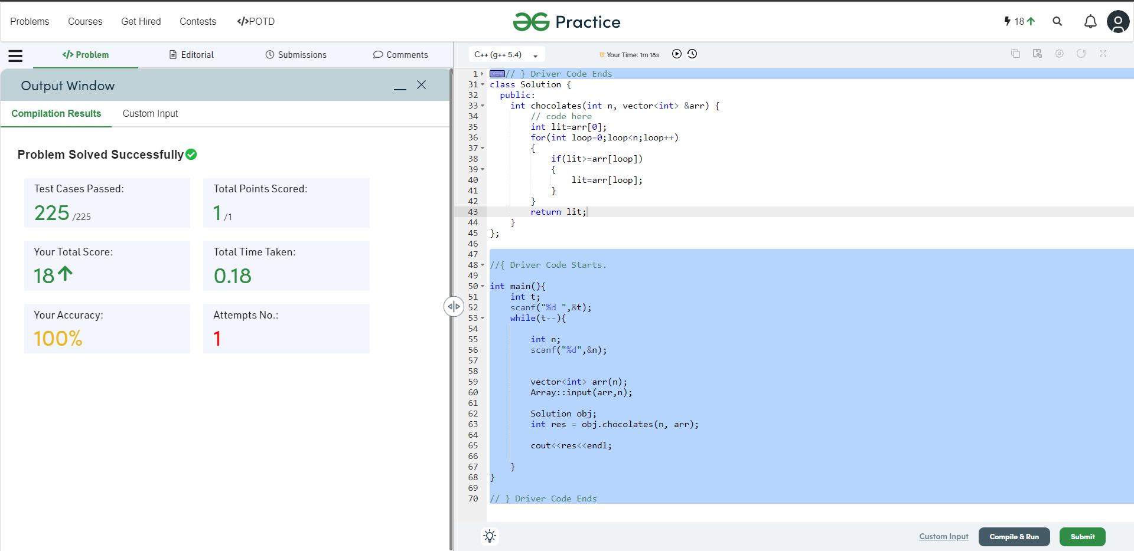

**Understanding about problem:**

* In this task there will be one array of numbers chocolate squares.
* In this task I need to return smallest chocolate square.

Note: If you can't understand the problem, feel free to contact us and we'll help you. Please don't copy and paste from anywhere.

ALL THE BEST

Team CP Club